Flash Light SWAP: Girl Scouts Light the Way!

Supplies:

Golf Tee

Yellow Bead

Marker

1. Glues the yellow bead on the tip on the golf tee.
2. Use marker to draw on switch.
3. Mount on Paper to attach safety pin (optional)

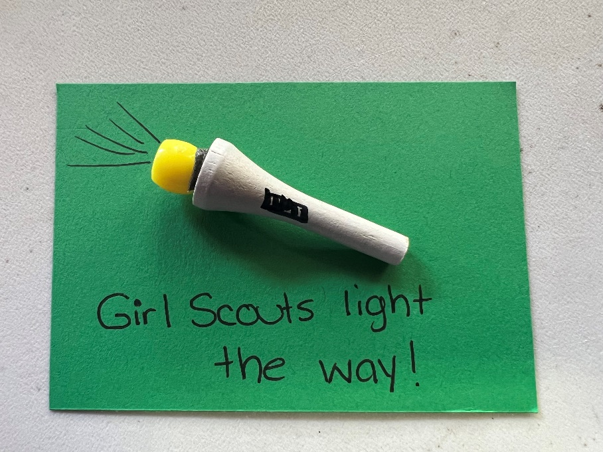

Activity – Pony Bead suncatcher

Supplies –

See through pony beads

Muffin Tin OR Baking Sheet/Aluminum Foil/Cookie cutters

Oven, Toaster Oven or Grill

1. Preheat oven to 350.
2. Line baking sheet with aluminum foil.
3. Place cookie cutters onto baking sheet and fill with pony beads. You can arrange in a patter neatly, or just dump them in.
4. Bake for 15-20 minutes, or until melted and flattened.
5. Allow to cool before removing cookie cutters.

\*Note- it does smell like burning plastic. If this bothers you, you can bake these outside in a toaster oven or grill.

